

sMaRT DesigNZ– Product Catalogue
Company Information
- Name: sMaRT DesigNZ
- Business type: Custom 3D-printing and modeling shop.
- Description: A small, independent printing business in Ohio specializing in custom 3D prints — from large custom part molds to simple decorative models. If it can be modeled and printed, sMaRT DesigNZ can do it.
- Team size: ~6 people.
- Contact: Office phone: (330) 843-3333
- Hours: Monday–Friday, 9:00 AM – 5:00 PM
Services & Example Products
Custom Fit Printing
We can print custom items of almost any size — from small parts to large molds.
Use cases:
- Custom parts for machinery or repair
- Prototypes or functional parts
- Unique components not available commercially
Templated Prints
Choose from a variety of templated 3-D models for common needs — e.g. support parts, phone-case molds, standard fixtures.
Use cases:
- Affordable molded products using pre-designed templates
- Repeatable designs without the need for custom modeling
- Quick turnaround for standard items

3-D Modeling + Printing
If you don’t have a 3D model, sMaRT DesigNZ can assist in 3D-model creation and also complete the printing — all in one place. zanehoch23.wixsite.com
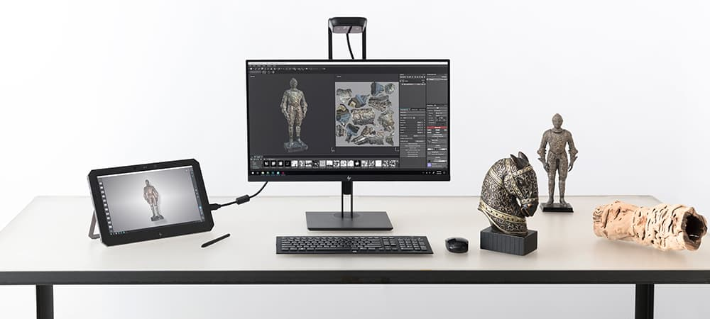
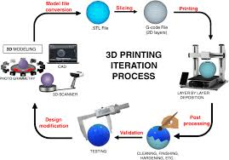

Use cases:
- Custom designs from scratch
- Unique items tailored to specifications
- Functional and decorative prints
Hardware / Printing Equipment (Used In-House)
sMaRT DesigNZ uses the following printers for different tasks:
Printer | Purpose
Aura PrintMax 8000 (FDM) | Clean, precise prints in all shapes and sizes.
Ender 3-X | Faster, smaller jobs. Great for quick-turnaround prints.
Eno 43 Pro (SLA Resin) | For highly detailed, high-resolution prints — ideal when detail matters.
(Note: these are internal tools; not products for sale directly, but they indicate the capability and quality level of sMaRT DesigNZ service.)
How To Use This Catalogue
- Review the services and choose the category you need (Custom Fit Printing, Templated Prints, or 3-D Modeling + Printing).
- Decide whether you need fast, small prints or large, detailed jobs.
- Contact sMaRT DesigNZ at (330) 843-3333 during business hours to request a quote or start your order.

